1. File -> Project Structure (Ctrl + Alt + Shift + S)

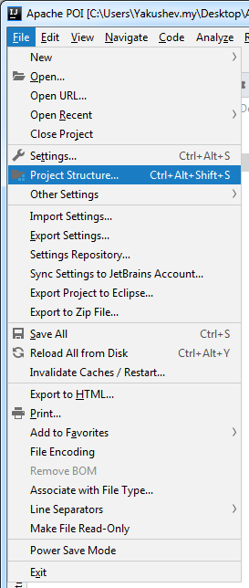

1. Libraries -> Plus -> Java

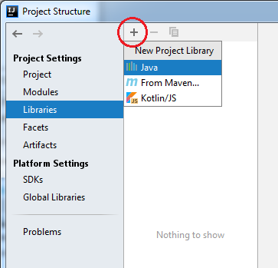

1. Выбираем \*.jar -> Ok -> Ok

